**Operational Concept Document**

**Pluggable Code Repository**

Jim Fawcett

CSE681-OnLine

Software Modeling and Analysis

June 3, 2017

1. Executive Summary
2. Concept
   1. Store large evolving software baseline
   2. Adapt to Engineering Organization’s processes
3. Uses
   1. Developer’s activities
   2. Quality Assurance work flow
   3. Manager’s need for progress information
   4. Customer Code Maintenance
4. Structure
   1. Packages
      1. Concept
      2. Packages
      3. Responsibilities
      4. Package diagrams
   2. Operations and Activity diagrams
      1. Concept
      2. Activities
      3. Sequencing
      4. Activity diagrams
5. Critical Issues
   1. Integrity
   2. Ease of use
   3. Size of the working set
   4. Defining interfaces rich enough language vs. simplicity
   5. Conflicting user activities
6. Risks
   1. External attacks
      1. Integrity
      2. Loss of proprietary value
   2. Internal attacks
      1. Integrity
      2. Loss of proprietary value
7. Conclusions

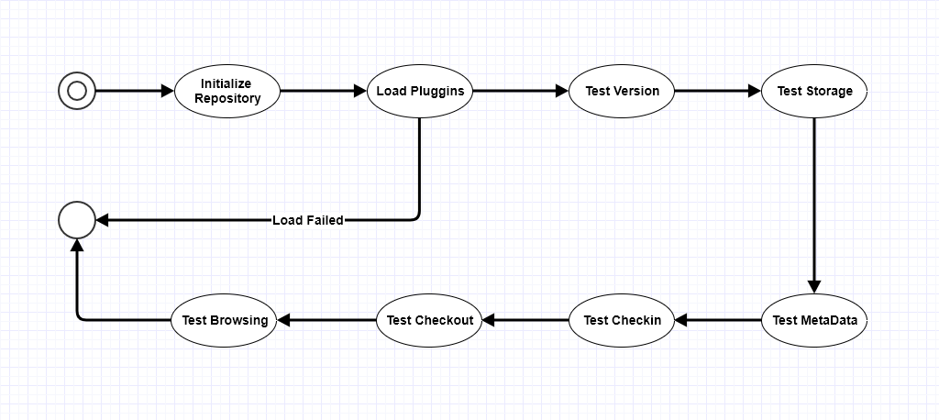

**Figure 2 – Pluggable Repository Activity Diagram – First and Second Projects**

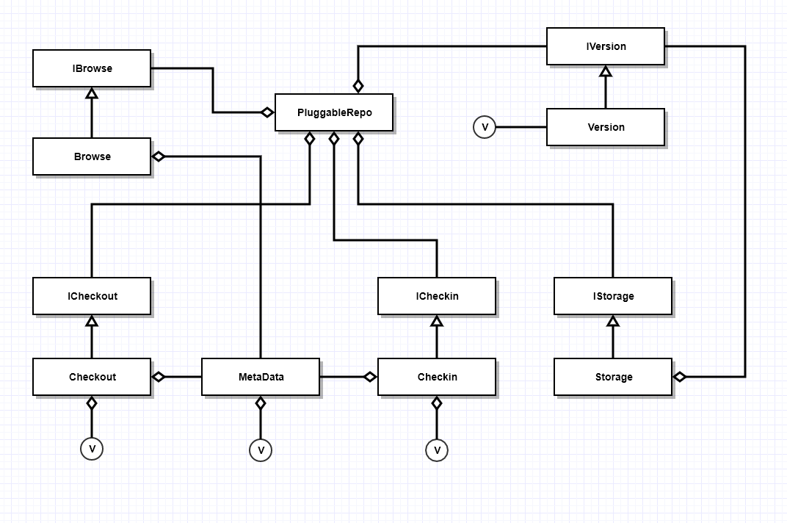

**Figure 3 – Pluggable Repository Class Diagram – First and Second Projects**

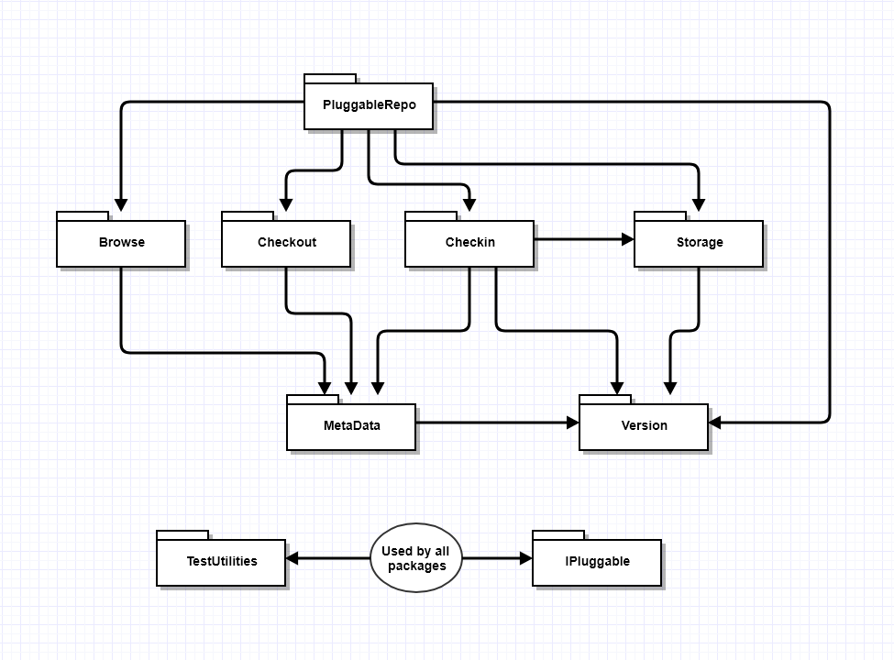

**Figure 1 – Pluggable Repository Package Diagram – First and Second Projects**

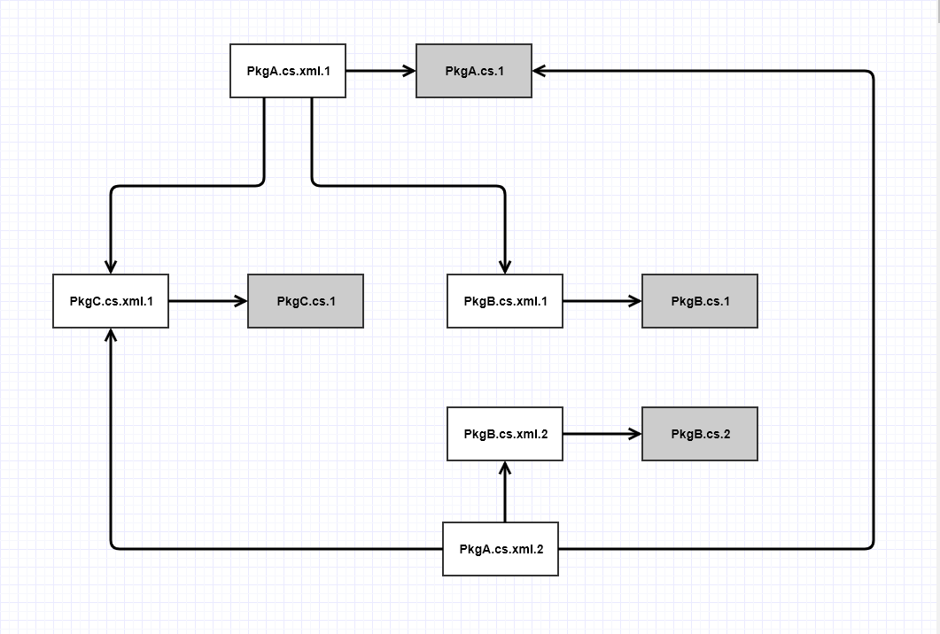

**Figure 4 – Storage Structure with Versioned MetaData**